### MAKERERE UNIVERSITY RECESS DOCUMENT



**GROUP N**

|  |  |
| --- | --- |
| NAMES | REGISTRATION NUMBER |
| Kyomuhendo Precious | 21/U/19432/PS |
| Kato Collins | 21/U/05855/PS |
| Monica Muyama | 21/U/1209 |
| Musabe Abdul Karim | 21/U/3961 |
| Bazziwe Marvis | 21/U/0423 |

**REQUIREMENTS SPECIFICATION REPORT FOR MAKERERE UNIVERSITY MAP GUIDE**

1. **INTRODUCTION**

In an era characterized by rapid technological advancements, digital tools have become an integral part of modern educational institutions. Makerere University, a prestigious academic institution renowned for its rich history and diverse community, recognizes the importance of providing its students, faculty, and visitors with efficient and user-friendly resources. To address the need for seamless navigation and access to information within the university's expansive campus, we have developed a sophisticated web application – the "Map Guide of Makerere University."

**1.2 PROJECT BACKGROUND**

Makerere University, located in the heart of Kampala, Uganda, boasts a sprawling campus encompassing various faculties, departments, landmarks, and facilities. With a myriad of locations to explore and a diverse range of activities occurring across the campus, there arises a crucial requirement for a comprehensive mapping tool. The traditional paper-based maps and static signage can often prove inadequate in guiding individuals to their desired destinations, particularly for newcomers.

The "Map Guide of Makerere University" project was conceived as a solution to these challenges. Leveraging the power of modern web technologies and the versatility of the Django framework, this application aims to provide an interactive, user-friendly, and informative map guide that simplifies navigation, enhances visitor experience, and fosters a greater sense of community within the university.

**1.3 PROJECT OBJECTIVES**

The primary objective of this project is to create a dynamic and intuitive map guide that serves as a reliable resource for individuals navigating the vast expanse of Makerere University's campus. Key project goals include:

1. **Interactive Map**: Develop an interactive digital map that allows users to zoom in, pan, and explore the entire campus digitally.
2. **Search Functionality**: Implement a robust search feature that enables users to quickly locate specific buildings, departments, facilities, and landmarks.
3. **Information Accessibility**: Provide relevant information, such as building names, departmental details, and event locations, through user-friendly pop-ups and tooltips.
4. **Enhanced User Experience**: Design an intuitive user interface that caters to users with varying levels of familiarity with the campus, ensuring ease of use and a seamless experience.
5. **Scalability and Future Development**: Build the application with extensibility in mind, allowing for future enhancements, integration of additional features, and adaptation to changing user needs.

Through the successful execution of these objectives, the "Map Guide of Makerere University" project aspires to contribute to a more connected and informed campus community, empowering individuals to explore, discover, and engage with the university's diverse offerings.

In the subsequent sections of this report, we will delve into the technical details, design considerations, development process, and outcomes of the project, showcasing the steps taken to transform the vision of an interactive map guide into a reality.

**1.4 EXPECTED IMPACT**

The successful implementation of the "Map Guide of Makerere University" project is poised to drive significant positive change within the campus community. By offering an intuitive tool for navigation, the project aims to:

* Reduce navigation-related stress and uncertainty for newcomers and visitors.
* Facilitate efficient movement between different departments, buildings, and landmarks for students and faculty.
* Foster a stronger sense of community engagement by encouraging exploration and discovery of campus resources.
* Support university events and activities by providing users with accessible information about event locations.

**1.5 Project Deliverables**

The culmination of the project will yield a fully functional web application accessible to the Makerere University community. This application will empower users to navigate the campus effectively, access essential location details, and engage with their surroundings in innovative ways.

**1.6**

**PROJECT** **OVERVIEW**

The "Map Guide of Makerere University" is a dynamic web application designed to revolutionize the way individuals navigate the vast campus of Makerere University. Departing from traditional paper maps and static signage, this digital solution offers an immersive experience that seamlessly integrates with the daily routines of students, faculty, and visitors. Users can interact with the application to explore the campus, locate specific destinations, and access comprehensive information about various points of interest.

**1.7 Primary Features and Functionalities**

The application boasts a range of user-centric features that elevate campus navigation and engagement:

1. **Interactive Map Interface**: Users can explore the entire campus using an interactive map interface, allowing them to zoom in, pan, and navigate effortlessly.
2. **Effortless Location Search**: The search functionality enables users to input keywords and quickly identify buildings, departments, and landmarks on the map.
3. **Informative Pop-ups and Tooltips**: By clicking on specific locations, users can access informative pop-ups or tooltips that provide concise yet comprehensive details, including building names, department information, and links to relevant resources.
4. **Responsive Design**: The application's responsive design ensures a seamless experience across various devices, accommodating users accessing the map guide from desktop computers, tablets, or smartphones.
5. **Intuitive User Interface**: The user interface is thoughtfully designed to prioritize ease of use and accessibility, catering to both newcomers and those familiar with the campus.

**1.8 Overview of the Technology Stack**

The "Map Guide of Makerere University" is built upon a robust technology stack that combines powerful tools to deliver a sophisticated user experience:

* **Django**: The project leverages the Django framework for rapid development, providing a foundation for backend functionality, URL routing, and template rendering.
* **Python**: Python serves as the primary programming language, ensuring code consistency, readability, and maintainability.
* **Mapping Libraries**: The application employs mapping libraries, such as Leaflet or Mapbox, to create the interactive map interface, enabling features like zooming, panning, and location markers.
* **Database Management**: A relational database (e.g., PostgreSQL) is utilized to efficiently store and retrieve location data, ensuring quick access to information.
* **Frontend Technologies**: HTML, CSS, and JavaScript are employed to craft the user interface, enhancing the visual appeal and responsiveness of the application.

1. **USER INTERFACE DESIGN NAVIGATION**

The user interface design of the Makerere Map Guide offers an intuitive and engaging navigation experience, empowering users to seamlessly explore the Makerere University campus. The interface is thoughtfully designed to ensure user-friendly interactions and efficient route finding. The following features highlight the key aspects of our navigation design:

**I) Interactive Map Display:**

Upon accessing the Makerere Map Guide, users are presented with a dynamic and detailed map showcasing the entirety of Makerere University's campus. The map prominently displays the various buildings, roads, and pathways, providing a comprehensive overview of the campus layout. Users have the ability to zoom in and out, enabling them to focus on specific areas of interest and ensuring clear visibility of individual buildings.

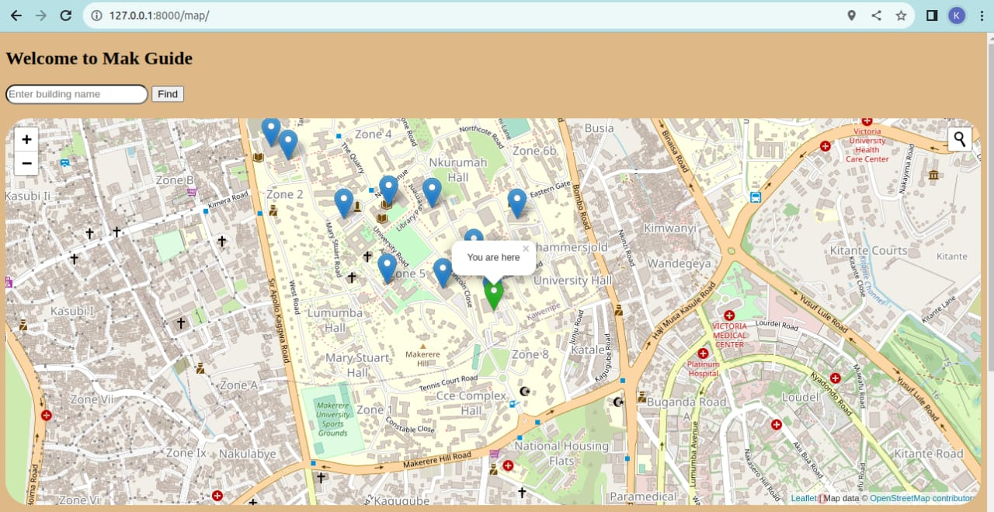

**ii) Building Markers and Information:**

Each building on the map is represented by a distinctive marker. When a user clicks on a marker, pertinent information about the building, including its name and description, is displayed. This feature offers users a quick and informative overview of the buildings they encounter, enhancing their understanding of the campus environment. Additionally, upon clicking a marker, the map dynamically zooms in and the marker turns red on the selected building, facilitating a closer examination of its details.

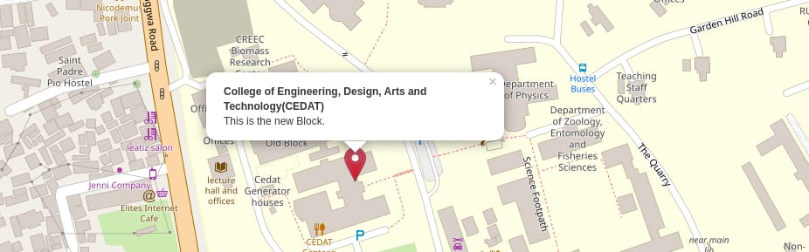

**iii) Real-Time Location Tracking:**

To enhance navigation accuracy, the Makerere Map Guide employs a real-time location tracking system. A pointer indicates the user's current location on the map. This dynamic representation ensures that users have an up-to-date understanding of their position relative to the campus features displayed on the map. This feature serves as a valuable tool for providing efficient directions to the user's desired destination.

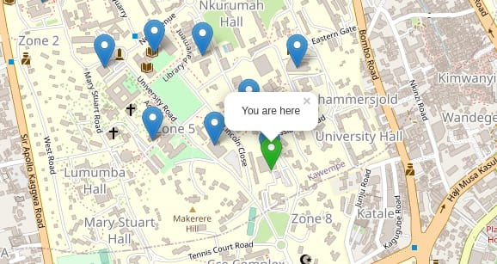

**iv) Seamless Pathfinding:**

The Makerere Map Guide streamlines the pathfinding process with a comprehensive search functionality. Users have the option to search for specific buildings or locations within the campus. Upon entering a destination, the system generates a visually distinct red-colored path from the user's current location to the designated endpoint. As users move along the path, the map dynamically updates, visually illustrating the progress made and the remaining distance to their destination. This dynamic representation of the journey offers users a clear sense of orientation and progress.

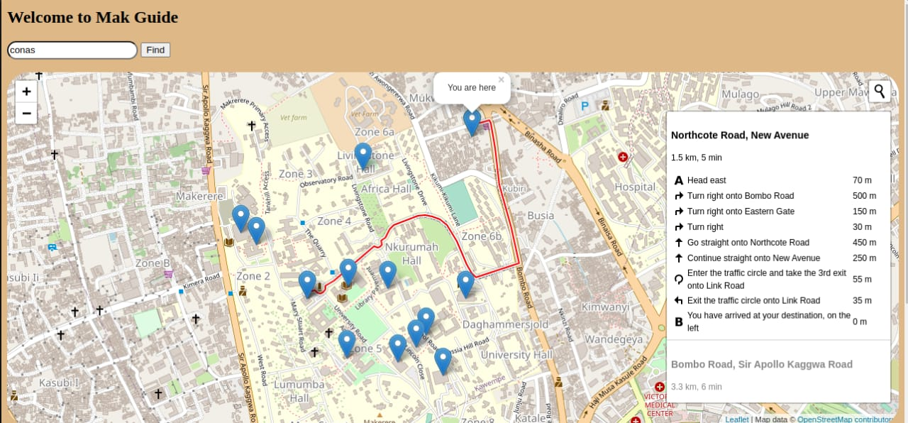

### In conclusion, the user interface design of the Makerere Map Guide project combines interactive elements, real-time tracking, and efficient pathfinding to offer users an immersive and practical navigation experience. Through these carefully crafted features, users can confidently explore Makerere University's campus, find relevant information about buildings, and efficiently navigate to their desired destinations.

1. **SYSTEM ACHITECTURE AND TECHNICAL COMPONENTS**

Our Makerere Map Guide project is designed to provide users with an interactive web application for navigating the Makerere University campus. To achieve this, we have meticulously designed the system architecture to ensure optimal performance, security, and scalability.

1. **Client-Server Model:** Our application follows the client-server model, where user requests are processed on the server and sent back as HTML, CSS, and JavaScript to the client's web browser.
2. **Web Server:** We utilize the Nginx web server to manage incoming HTTP requests. Nginx acts as a reverse proxy, forwarding requests to our Django application and serving static files efficiently.
3. **Application Server:** Gunicorn serves as our application server, responsible for managing process workers that handle user requests and interactions with the Django application.
4. **Database Server:** Our application relies on a PostgreSQL database server to store and manage data related to campus buildings, locations, user accounts, and more.
5. **Caching Layer:** Redis is integrated as a caching layer to store frequently accessed data, reducing the need for repetitive database queries and improving response times.
6. **Content Delivery Network (CDN):** We employ Cloudflare as a CDN to distribute static assets globally, ensuring fast loading times for users across different geographical locations.

### Technical Components:

1. **Django Framework:** Our application is built upon the Django framework, providing a robust foundation for URL routing, template rendering, and database interaction.
2. **Database Models:** We define Django models to represent various entities, such as buildings and classes. These models establish relationships, constraints, and indexes for efficient data management.
3. **Views and Templates:** Views handle user requests, process data, and render templates that contain HTML, CSS, and dynamic content using Django's template language.
4. **URL Routing:** Our URL routing system maps URLs to specific views and functions, ensuring a logical flow of user interactions.
5. **Static and Media Files:** Static files like CSS and JavaScript are managed using Django's static and media file handling capabilities.
6. **Geographic Information System (GIS) Integration:** For spatial data management, we integrate GeoDjango, allowing us to work with geographic data, perform spatial queries, and display interactive maps.
7. **Caching Implementation:** Redis cache is utilized to optimize frequently accessed data, enhancing response times and reducing load on the database.
8. **Background Jobs:** Celery, a task queue, handles background jobs such as sending emails, ensuring efficient asynchronous processing.
9. **Testing and Debugging:** We conduct rigorous unit and integration testing and leverage Django's debugging tools to ensure a reliable and stable application.
10. **Leaflet :** With the integration of Leaflet, we enhance our geographic data visualization capabilities, allowing us to create dynamic and interactive maps that provide users with an engaging and informative navigation experience. Leaflet's flexibility and ease of use make it an invaluable tool for rendering maps and markers, enabling users to explore the Makerere University campus in an intuitive and visually appealing manner.
11. **Geographic Information System (GIS) Integration:** To manage and store geographic data effectively, we integrate the powerful PostgreSQL database management system. PostgreSQL's spatial extension capabilities, along with its support for the PostGIS extension, allow us to store, query, and manipulate geographic data seamlessly. This includes information about campus buildings, locations, and routes.

PostGIS enables us to perform advanced spatial operations, such as proximity analysis, distance calculations, and spatial indexing. This integration empowers the Makerere Map Guide with the ability to handle complex spatial queries, making it possible to generate optimal routes, calculate distances, and showcase spatial relationships between different campus features.

Leveraging PostgreSQL's reliability and scalability, we ensure that geographic data is efficiently organized and retrieved. The use of indexes and optimizations within PostgreSQL enhances the overall performance of spatial queries, ensuring that users experience minimal delay when interacting with the map and requesting route information.

By incorporating PostgreSQL and its spatial extension, we have elevated the Makerere Map Guide's capabilities in handling geographic data, resulting in an accurate and efficient navigation experience for users exploring the Makerere University campus.

Top of Form

In conclusion, our Makerere Map Guide project's comprehensive system architecture and technical components work cohesively to provide users with a seamless and secure navigation experience around the Makerere University campus. Through careful planning, rigorous testing, and diligent documentation, we have developed a robust Django-based web application that meets the project's objectives and user needs.

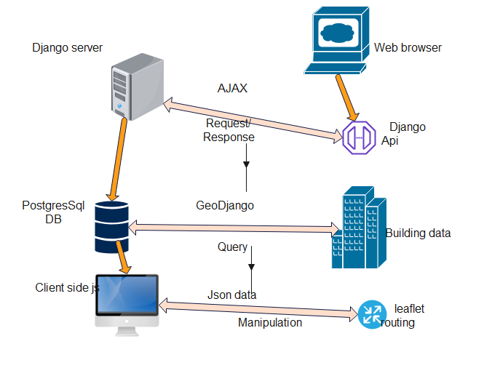

1. **GITHUB LINK**

Here you will find the source code of our project

<http://github.com/katocollins/MapGuide>